Day 5 - Bash Scripting

Syntax for all loops

1. While loop

Syntax:

While <condition>

do

command 1

command 2

done

example :

#!/bin/bash

a=1

while [ $a -le 10 ]

do

echo "value: $a"

((a++)) # Increment the counter

Done

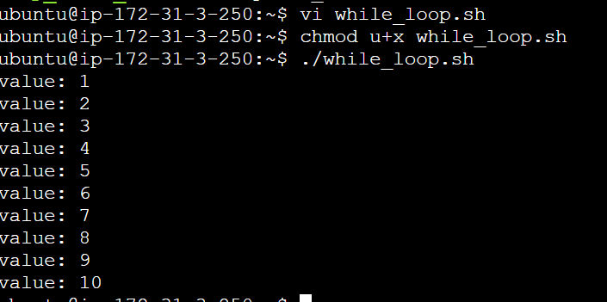

1. For loop

Syntax :

For val in <valu1 … val3>

do

command1

command 2

done

example :

#!/bin/bash

for i in {1..10}

do

echo "i : $i"

done

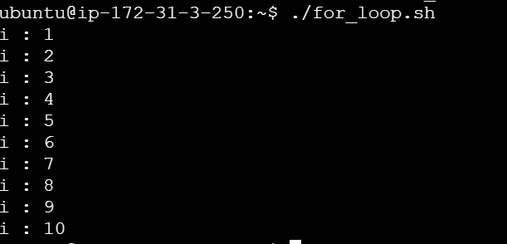

1. Until loop

Syntax :

until <condition>

do

command 1

command 2

done

example :

#!/bin/bash

a=10

until [ $a -le 1 ]

do

echo "value: $a"

((a--))

done

